The skinny:

2000 words. This is a maximum. It should most definitely be a struggle to reduce to 2000 words. If it’s a struggle to get TO 2000 words, that’s a problem.

- Title page with name of film, your role, 50 word logline and a word count.
- Contents page
- Creative work in my one film production role (1000 words)
- Collaboration with my core production team (1000 words)
- Bibliography (research texts and films.)

I’ll mark it ONCE for you, in painful detail. Get the most out of that exceptionally generous offer by:
- Gathering the materials – screenshots, research texts, photos on set, evidence of rehearsal and successful or unsuccessful collaboration and so on- as you go through the process of making your film.
- Plan it in detail. (However detailed the plan is, it’s not detailed enough.)
- Submit a complete draft in good time; assume you will have to fundamentally rewrite it. Rewriting often takes longer than drafting.
- Understand what you’re aiming for.
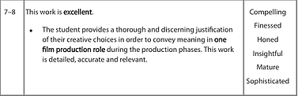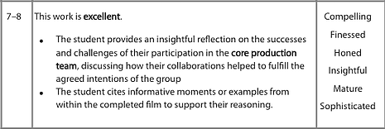

Yeah, I know. It’s not very helpful. But look at those words – thoughtful, discerning, detailed, insightful. It takes genuine reflection and a certain amount of time to get to that level. You can’t do it quickly.

CREATIVE WORK IN MY ONE FILM PRODUCTION ROLE (a.k.a., the easy bit.)

“Work in this section of the film report should include the student’s justification of the creative choices made in order to convey meaning in the completed film in their one chosen film production role. Discussion is likely to evidence the creative work undertaken during the pre-production, production and post-production phases and the ways in which their production skills, techniques and/or approaches were effectively deployed in order to convey meaning and to contribute to the overall effectiveness of the film."

- Don’t walk us through the entire journey of the film. Most of what you did is pretty much the same as everyone else.
- They want evidence of your ‘creative choices.’ You need to think of places where you actually exercised your creativity, where you had options and labored to make a decision, where what you did positively influenced the outcome of the film.
- They do want evidence of your involvement in all stages of the film – pre- to post-production. So, a cinematographer might show how they marked up a script, turned (part of) that into a storyboard/ blocking diagram/ lighting scheme, set up the location/ lights camera, shot the scene and then collaborated with the editor with colour correction. Do that a few times and they will get a strong sense of how you generate ideas then take them through to fruition.
- They need you to explain how your creative choices ‘convey meaning’. You need to analyse your own shots or editing style or characterization or whatever. Respect your own work – analyse it like it’s Kubrick. Detail matters. If you can’t find anything to say, that’s because you didn’t put much into it in the first place. Pick another part.
- They want you to address the ‘overall effectiveness of the film.’ Your last few sentences in this section need to be about how successful the whole film is. Usually the answer will be ‘it’s good but…’ Remember, for the top marks, they want a sophisticated and insightful answer.
- By the way – if you have music in your film, everyone needs to talk a little about how it was sourced. (No, I don’t know why either.)
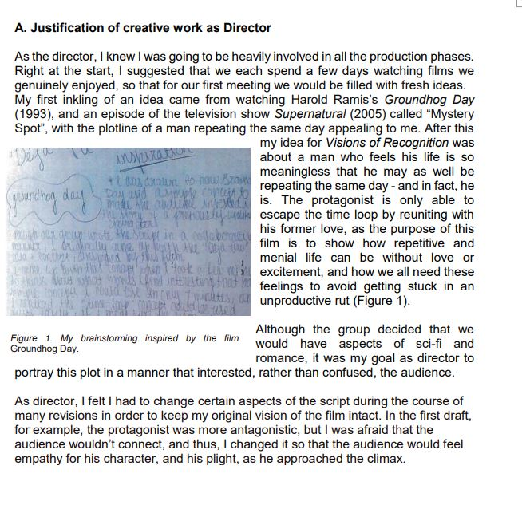
EXAMPLE A – superficial and bland. Waffle. Thoroughly bad. Meh. Level 3.

EXAMPLE B - 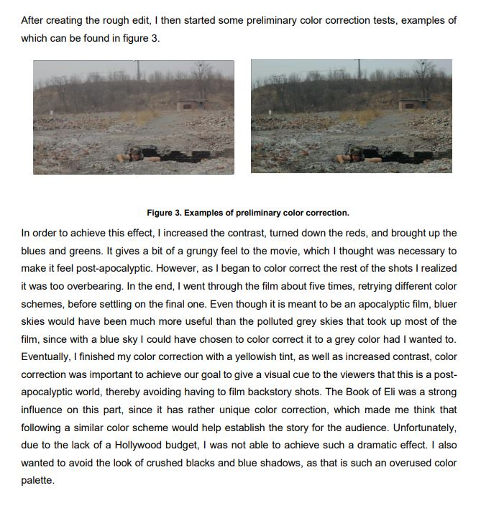

EXAMPLE B – this is better. (Could still have a lot more supporting evidence though.) Maybe a Level 6. Woo-hoo!

COLLABORATION WITH MY CORE PRODUCTION TEAM

“This section should begin with a clear statement of the core production team’s agreed intentions for the film. Work in this section of the film report should include the student’s reflection on the successes and the challenges of participation in the core production team and involve discussion on the ways in which their collaborations helped to fulfill the agreed intentions of the group. Discussion is likely to evidence the student’s work beyond the one chosen film production role and their approaches to effective group work (through problem-solving, giving and receiving constructive feedback, supporting others, working flexibly, reliably and responsibly and so on). Reflecting on collaboration does not mean that students should see this as an opportunity to complain, blame or criticize the role of other core production team members. Students should cite informative moments and examples from within the completed film to support their reflection.”

- This bit might be harder for most people, so leave time to do it well.

CAN YOU WRITE ABOUT ANY OF THESE?
- Manage time effectively (set and meet deadlines, schedule meetings, produce a production schedule, update and keep to it…)
- Set realistic objectives, priorities & standards. (Shared logline of film, meeting minutes, regular contact with all members of CPT.)
- Monitor, evaluate and adapt own performance. (Seek feedback at all stages, find ways to keep everyone in CPT up to scratch.)
- Evaluate your own potential (Know thyself. What are you god at? What are you weak at? Does someone else in the CPT make up for your shortcomings?)
- Show intellectual flexibility (be willing to see that there may be more than one way to solve a problem. It is hard for most people to simultaneously think something is correct and that there is a chance it may be wrong.)
- Take responsibility for acting in a professional/ethical manner
- Deal with criticism constructively. In fact, actively and intelligently seek criticism.
- Take on extra work for the good of the project

“After the editor looked at the rushes, he told the director that the footage wasn’t good enough because the shakiness impacted the continuity of the edit, and I had to accept he was right. It wasn’t easy but I could see he was right. On the next shoot we used a ball head tripod so I could have maximum options for tracking the character from a stationary point. The urgency in the end was created from a combination of panning, pushing in, and quick, continuous cuts and the results were more effective…The director was in a rush to capture the light, and wanted to skip setting up as we agreed. While I understood his point of view, I had to stand up for using the tripod as I knew that we couldn’t sacrifice.”

This student is showing how collaborative decisions and practices ultimately affect the actual film. This is where you want to get to (but provide evidence of everything you say also.)

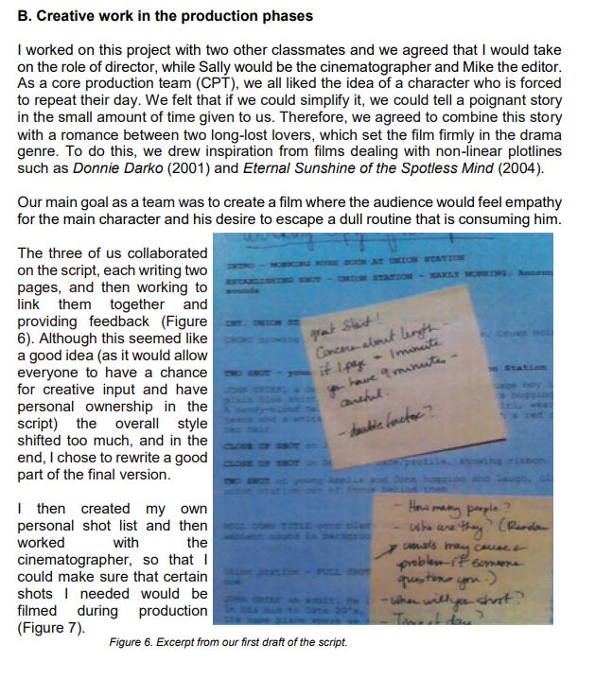

This is pretty vague and waffly. There is little actual detail and there is nothing to help us determine whether this is good collaboration or bad collaboration. Maybe level 3.

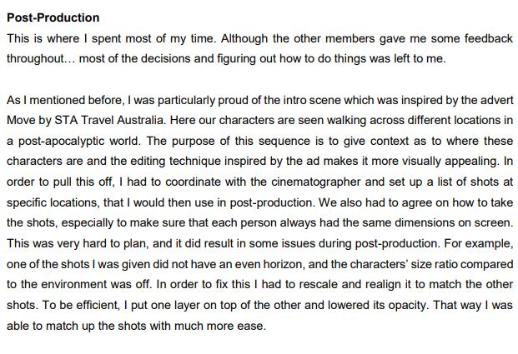

Better. Detailed, linked to actual film production processes and tied to a particular bit of the film (though we need the supporting evidence.) Level 6 or maybe 7 if supported.

