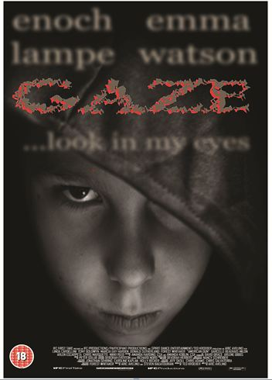
I made a poster for a horror film called ‘Gaze.’ On top of the visual hierarchy is a close-up, slightly low angle shot of a boy’s face. He is gazing directly at the camera (to link with the title and the tagline, ‘Look into my eyes’, which foreshadows what the plot of the film is about) and his facial expression connotes fear or threat which is appropriate for the genre. I used chiaroscuro lighting – one point lighting with the key light positioned below the subject’s face - because that is a convention of the horror genre and it connotes conflict and extreme emotion. I used a close up to make the image look somewhat intimidating and intense.
The graphology uses a red and grey palette – I used red because it connotes death and blood and again it is conventional of the horror genre. I edited the font to make it look ragged and torn to suggest violence and destruction. However the red is not bright or eyecatching enough and I really should have made it more vibrant.
The layout is very conventional. The image forms the background and other elements work around it. The actors’ names are at the top because they are actually the most important thing; people usually go to see films with their favourite actors in. Below that is the title, which is also obviously very important, and the tagline. I think I probably put too much text at the top of the image and it now looks unbalanced. Basic elements – the credit block and the certification – are positioned at the bottom where they will take the least possible amount of attention away from the more important parts of the poster.
I think I did quite well but I could have been more adventurous and ambitious, especially with the layout. I could also have included some other elements, like reviews from critics or links to other films by the same director. Next time, I will need to aim a little higher and make sure I am including all the possible elements and to be more creative in the decisions I make.

