Produce research into your own film idea.
​
As part of your Unit 4 (Video Production) work, you will develop an idea for your own short film. Working independently, you need to perform and produce research to test the viability of that idea. This research will form part of the pitch for your film.

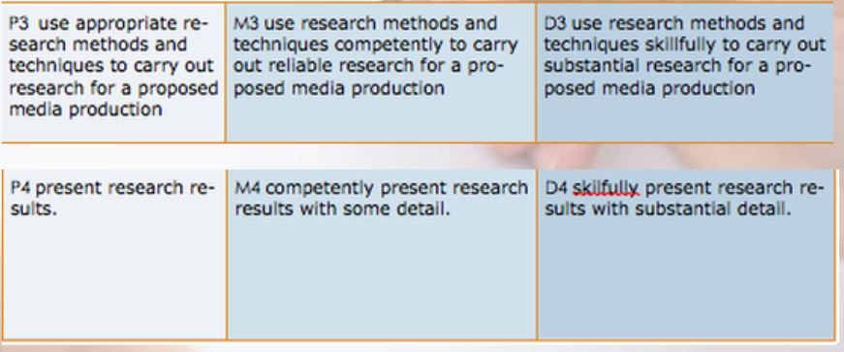
Suggested Plan

- Choose your genre/ sub-genre or hybrid. (e.g., horror/ slasher or horror/ psychological or horror/ comedy)
- DESK RESEARCH. Watch some examples. Try here. Note – some of these are for adult audiences.
- You are trying to become an expert in this genre. Make notes. Use a template, maybe like the one on this page – or feel free to make your own. Do a little web o rinternet research also to see if you can find out more about your genre.
- AUDIENCE RESEARCH. Figure out who you are targeting and what they want. Show a couple of the best examples you found to a group of people and see what they think. (Focus group.) Make a few notes on what draws people to your genre (uses and gratifications.)
- PRODUCTION RESEARCH. What kit do you need? Are there any processes – special effects or whatever - you need to master? Find some tutorials. What software do you need? What locations might you need? How many actors? How long will you need to make this thing?
- MARKET RESEARCH – What examples of your genre have been successful, whether financially or in terms of prizes and reviews? Find out the box office, the merchandising take, and sum up the critical response (metacritic is handy here.) Present your work appropriately, as you did for the second task. (SO, contents, page numbers, bibliography, labelled diagrams, introduction and conclusion…)

