Some ideas for a movie trailer
BASIC ADVICE
Emphasise whatever you think might be weakly represented in the OTHER parts of your portfolio. If you haven’t really shown much technical or organisational skill, or creativity, or understanding of film language, do it now! That’s what the trailer is for.
IDEAS
- The standard trailer. The best bits of your film. Emphasise the narrative- the opposition or enigma. Have a voiceover. Record it well. Get the music organised early. Think about increasing and decreasing pace. Have killer graphics. ‘From the makers of…’ Studio logos, certifications. ALL THE STUFF NORMAL TRAILERS HAVE!
- Start with the ending of your film. How did we get here?
- Introduce your characters. Show them living their lives.
- Introduce the location.
- Introduce the director.
- Show how your trailer follows ‘the rules’ of trailers.
- Have a split screen. Two of your characters talking.
- Have many split screens. All your characters.
- Reverse some footage. Turn the clock back.
- What happened before the film? Trailer as prequel.
- What happens afterwards? Trailer as sequel.
- The police investigation into the events of your film.
- The marriage of two people in your trailer.
- A doctor talking about synaesthesia.
- Stop motion.
- A photobook of the best stills from your film.
- Painfully fast editing (see A Clockwork Orange.)
- Desaturate it. Everything looks better in black and white.
- Desaturate it but isolate one colour to keep.
- Completely silent trailer.
- Trailer based around text.
- Play with the speed of your footage. Ramp it up and down.
- Third person / minor character account of the initial meeting or key event in the film. The waiter in the restaurant who saw the couple’s first meeting.
- Frame it as a film lesson. Voice over analysing a scene.
- Reunion of the characters years later.
- The characters as children.
- News report into the events of the film.

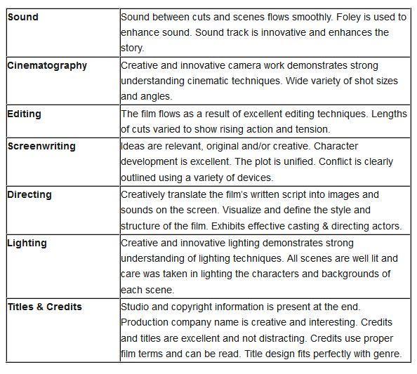

CHECKLIST
Music
Voiceover
Certification
Studio ident
Actor’s names
Film’s name
Director’s name
Enigma
Conflict

