- Where are the colour correction tools?
- Load your video
- Open the Inspector (command-4)
- Go to ‘video’ tab
- Hit the reveal arrow beside ‘Correction 1’

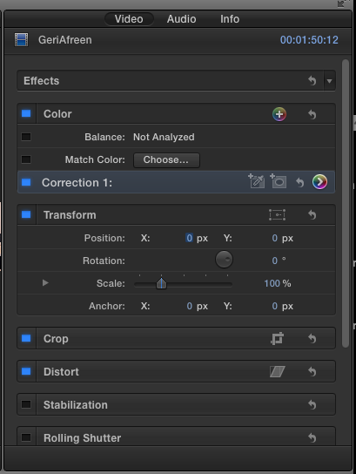

- EXPOSURE
- Hit ‘exposure’ tab at top
- 4 controls – global, shadows, mids and highlights.
- Open a scope – go for Luma Waveform. Now you can actually see what you are doing.

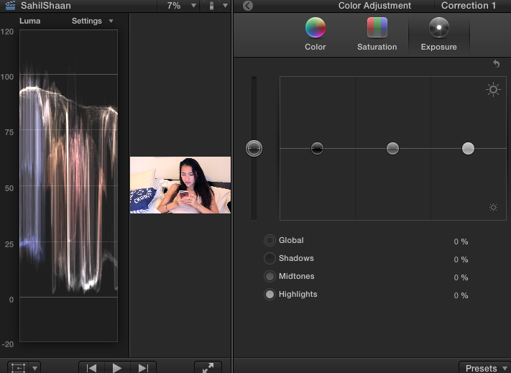
Scopes available here – under ‘settings’
- Luma waveform measures your dynamic range from -20 to 120. O is totally black, 100 is totally white. Not much point going beyond them., but there is a lot of value in going TO them, that is, using the full dynamic range. Drop the shadows to get to 0, raise the highlights to get to 100.

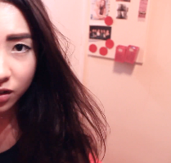

- COLOUR
- Hit ‘colour’ tab at top of inspector
- Change scope to RGB Parade. You basically want some balance over these three colours, This image tends towards the blue end – so it’ll be a bit ‘cold.’ (It’s also not exploiting the full dynamic range, so let’s sort that out first!)
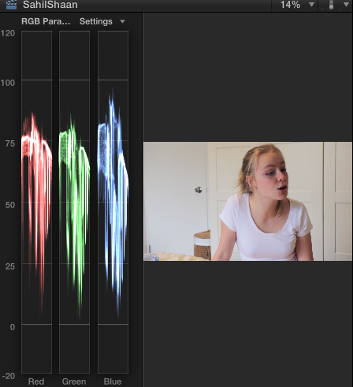

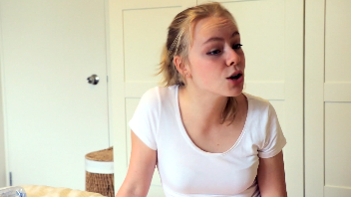

Bear in mind – there are no rules. This is a chick flick, so the editor might want a little more red or pink in the palette. But this is how it looks when it’s balanced. Keep an eye on skin tones – make them look good first and foremost. And note that adjusting colour affects exposure, so you might want to leap between the luma and colour scopes to make sure you’re not negatively affecting things.

- SATURATION
- Click saturation tab at top of inspector.
- Change scope – go to vectorscope. It has colours ranged around the outside of the circle. The line is called the ‘fleshtone line’ and that is where, in theory, the flesh tones in your image should be. Go for richness, not blurriness! A little saturation goes a long way… no orange people, please.

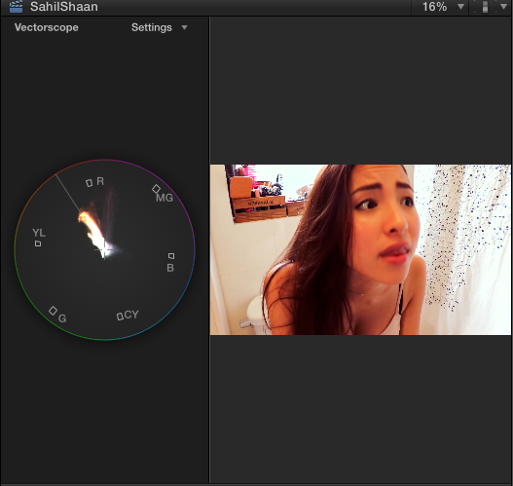

What looks good or bad is up to you… but film needs to be corrected. Personallu, I think this is a little flat because the guy’s face is too similar in tone to the background.

Corrected, it might look like this.

