IB English A: Learner Portfolio

Persepolis by Marjane Satrapi

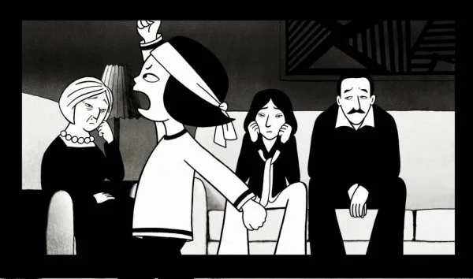

May and June 2020

Introduction

IB English A courses require all students to maintain a Learner Portfolio for the duration of the two year course. This portfolio will act as a record of your engagement with the course. It will be where you record both process and product: reflections, annotations, essays and essay plans, along with any creative work that you do as part of - or inspired by - the course.

Your IB English teacher will set up the Learner Portfolio with you in August. During this introductory programme, you will complete all of your work in this document. Then, come August, you will copy and paste these pages into your Learner Portfolio - and the first ‘chapter’ of your study will already be complete.

Part One: An Introduction to Historical Context

Look at the image below (source). What do you know, think, and feel about what you can see?
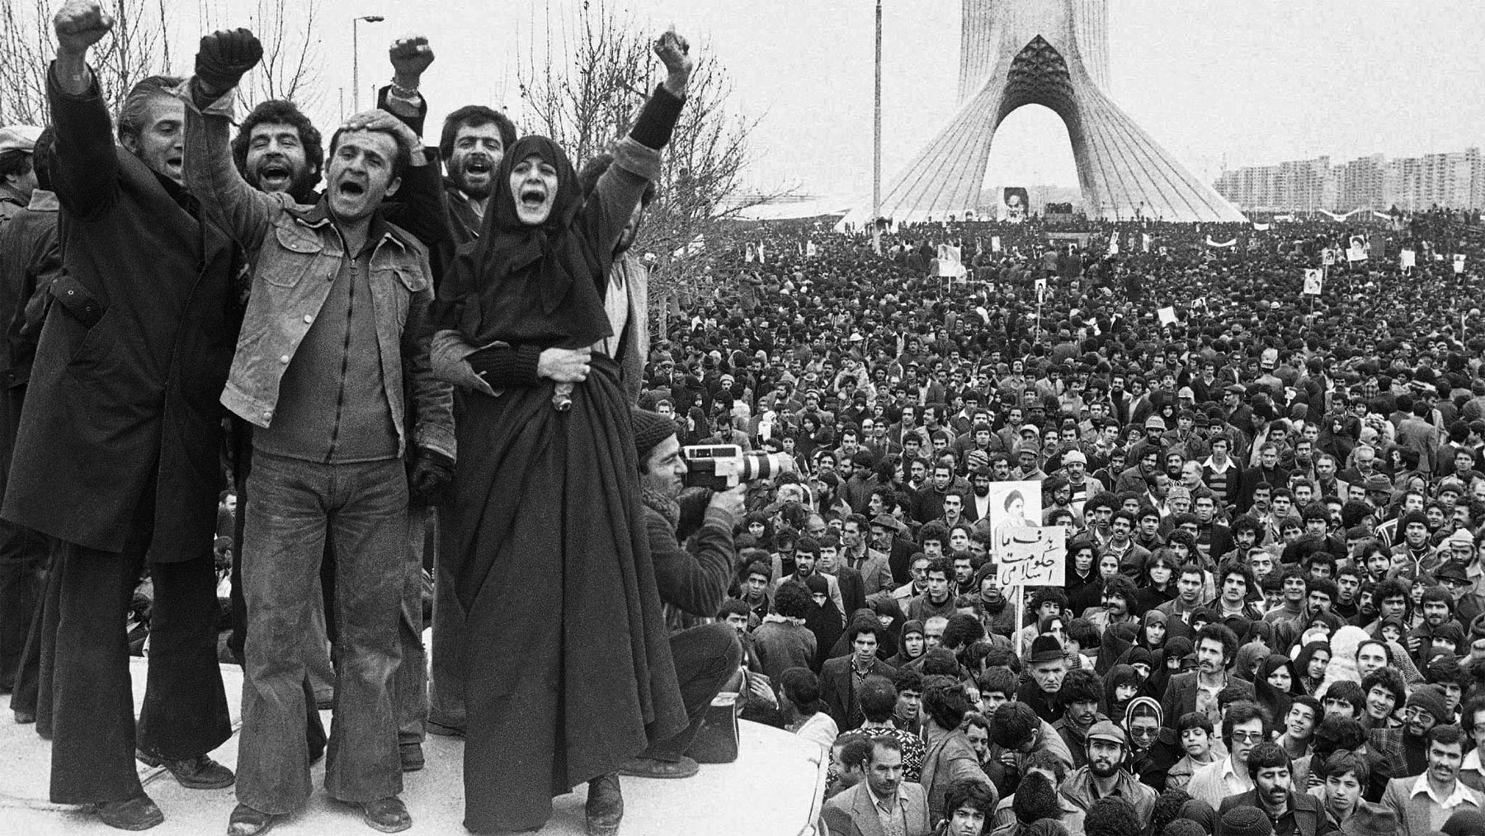
Write your response here:

What have you now learned about the Iranian Revolution? Use this space to take notes as you listen to the lecture.

Iran (1979): Anatomy of a Revolution
Al Jazeera documentary, first aired in 2009.
Watch again here.

Context | Facts | Analysis | Questions
Criteria | Information | Seems like…  I think….  I wonder…. | So what?  And?  What about?
Geography - Physical / Natural Resources /Political /
International setting
Social Structure
Economics - internal / external
Politics
Religion- Traditional vs Modern
Gender Roles
History
Leaders -legacy
Education
Literature
Role of media
Role of youth
Sources

Independent Research:

Part Two: Persepolis (2007)

While watching the film, please complete the following comprehension and reflection questions:

1. Describe Marji's childhood growing up in Tehran.

2. How does the Iranian Revolution impact Marji and her family? Cite specific examples of problems they personally face.

3. What problems does Marji experience after she leaves Tehran to live in Vienna? Which problems are personal to her or are a result of her being an expatriate?

4. When Marji returns to Tehran from Vienna, how would you describe her life?

5. The film shows some social and political contradictions and absurdities that result from radical fundamentalist interpretations of Islamic codes. Cite some of these examples from the film.

6. The film is a graphic novel brought to life in a black and white animation. Occasionally, the film moves to color. What might be the intentions of Marjane Satrapi and Vincent Paronnaud to use mostly black and white with rare use of color?

7. How would you describe Marjane's grandmother? What are her most important insights and suggestions for Marji?

Part Three: Exploration and Analysis

This part of your Portfolio is where you will store your annotations, analytical writing, and any reflective or creative work you do while studying the graphic novel. Your induction teacher will model to you what this should look like.

Graphic Novels - key techniques

