WHAT DO I NEED TO KNOW?

25% of final grade.
A script dealing with an aspect of Film History or Film Theory.
15 pages for HL, 12 pages for SL.
Must cover 4 films for HL, 2 for SL.
Films must be drawn from at least two film cultures which are not the student's own.
Must include a rationale and an annotated bibliography.
Audience is students aged 14-18.
TITLE FINALISED BY NOVEMBER 17
PLANNING COMPLETE BY 8 DECEMBER
ROUGH DRAFT DUE BY 19 JANUARY
FINAL DRAFT DUE 23 FEBRUARY
Final draft due on 28 October

HOW AM I ASSESSED?

Level 7:

21–25 There is an excellent understanding of, and engagement with, the film history/film theory topic. Engagement with the target audience, scope and depth of argument, the use of sources and structure of the script are excellent. Visual and audio elements are detailed, clearly and coherently described, and are aptly and proficiently linked. All films referred to clearly relate to the topic and insightful comparisons are made coherently and with precision.

Which means, you will be assessed on…

- Your knowledge of your subject
- How interested you seem to be in your chosen topic
- How interesting your script is
- How wide and deep your argument is – your understanding of the contest if your films
- How skillfully you link the two columns
- How well and technically you describe the video aspects
- How well you compare your films

WHAT ARE WE AIMING FOR?
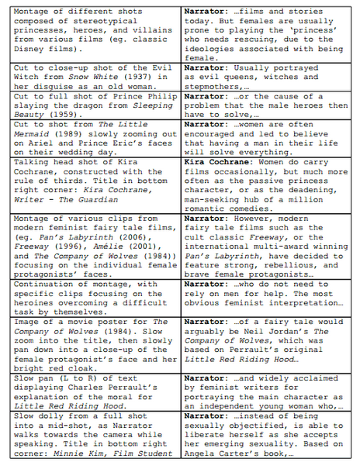

- Highlight where the student has shown:

- Many edits in the video column. Ranging across several films; not dealing with the films one-by-one.
- Shots described technically where possible
- Use of research sources as ‘talking heads’ in the audio column
- Film-specific vocabulary
- Fast-paced, lots of points, visuals keep changing.

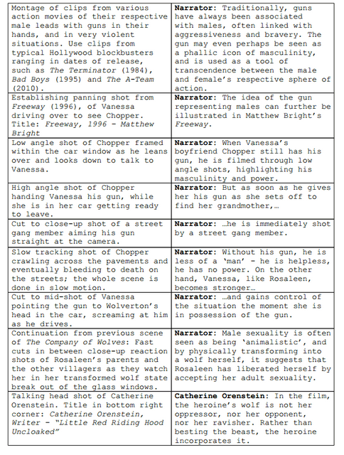
Highlight where the student has shown:

- Awareness of context
- Detailed analysis of films
- Use of sources
- Technical description of shots
- Film-specific knowledge

IDEA GENERATION

You could start with…

Then, ‘grow’ your idea…

E.g, I’m interested in ‘The Grave of the Fireflies’

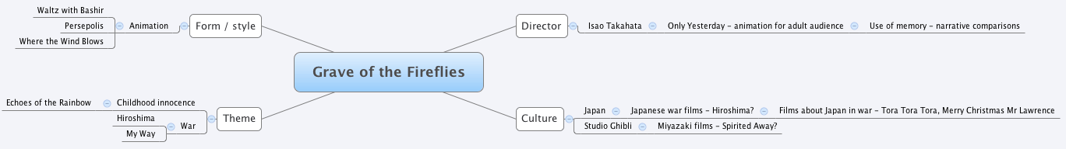

And MAKE NOTES. You are already starting to form ideas about linking films at this stage.

CHOOSING TOPICS

Think of topics you have covered or touched upon in Film this year. Typically, this will include such things as:

German Expressionism:
Cinematography
Conventions
Context
Narratives
Fritz Lang as auteur

Film Noir:
Context
Conventions
Ideology – nihilism, existentialism
Cinematography
John Alton as auteur
Narrative structures

Neo-noir:
Contexts
Cinematography
Dark City as influence on Matrix
Hybrid genre

Horror:
Vampirism as reflection of shifting locus of horror
Gender representation in vampire film
Feminist film theory
Representation in the slasher
Vampire movie as sublimated treatise on societal attitudes to sexuality
Revisionism of Horror Genre (And the Western)

Representation of youth in The Fall

Baz Luhrmann:
The musical
Auteurship
Australian film
Representations of youth

Italian Neo-Realism:
Context
Differences from studio film
Representation of poverty; compared to non-realist representations
Representation of elderly people
De Sica and Zavattini as auteurs
Cinematography / editing styles

Dogme 95
‘Vow of Chastity’ as compared to Italian Neo Realist and FNW manifestos
Influence of FNW and Italian Neo-Realism

French New Wave
Changes in style
Rejection of earlier genres, styles, ‘rules’

Documentary
Representations of ‘truth’
Conventions
Different types of documentary

It is a good idea to root your IS in something you have studied; you should be able to tell us what the aspect of Film History or Film Theory is that you are focused on. Big concepts include narrative, genre, representation, ideology, auteurship, gender and the whole technical realm (cinematography, writing, editing, sound design, directing.) Which of these are you actually focused on?

CHOOSING FILMS

Ideally, choose films you like; more importantly, choose films you can talk at length and in detail about. Read about them and make sure there are as many points of comparison as possible– in style, director, period, culture – something – you can explore. Don’t choose films only linked by one thing if you can help it, because you’ll end up explaining that one thing for fifteen pages.

PRO TIP: Very successful students generally come up with a few different ideas but quickly bite the bullet and choose one. And they NEVER change their idea once it’s established. Students who struggle generally fail to engage from the very start; it is a bad sign when the teacher has to find films or frame questions for them.

WATCHING FILMS

Watch your films. Watch them on a big screen, with your full attention, and take some notes. Then watch them again on a laptop (easier to take screen grabs) and make LOTS of notes. If you can’t recite the lines along with the actors, you don’t know your films well enough. Watch them with other people. Look up forums about them and get involved in the discussion. We learn a lot by engaging in discussion; there’s no excuse not to get involved. Email me or your other teachers to tell us what you thought. I’ll watch all your films and discuss them with you forever IF I think you’re putting in the effort to deserve help.

Choose the scenes you want to focus on. Analyse them to death.

Watch OTHER films. This is what you should be doing over the summer between Year 12 and Year 13. Watch other films by the same directors, from the same countries, about the same things… whatever. Make yourself an expert on your topic, because that’s what Level 7 means. Watch the DVD extras. (Note; it makes a lot of difference if you can actually buy the DVD as opposed to downloading or streaming the film. At least download the extra content as well.)

RESEARCH

More than anything else, this is a research task; the thing it is most similar to is the Extended Essay. As such, you have some work to di and, in this regard at least, IB is a very fair course; very simply, the more work you do, the higher your final grade will be, and deservedly so.

Start with Google. Read EVERYTHING that is relevant. Search your films, the genre, the directors, the movements, the film concept and period you are researching. Use smart search terms. (Googling ‘Japanese Horror’ is not actually a lot of use.) Search academic sites, fan sites, forums. MAKE NOTES. RECORD REFERENCES. BE ORGANISED.

Look at your website. There are links to good research sites on the front page. Use them follow links, read.

Go to the library. Introductory Film Studies books can be a lot of use. Are you studying the representation of Mexican women in American westerns? Read the chapter on Representation. Then read the chapter on Gender. Then read the chapter on Genre. None of it will mention Westerns or Mexicans but it will give you the vocabulary and theoretical tools that you need.

Stay in the library. Find out how to access the library databases. Questia is fantastic. Ask the librarian how to access past Extended Essays. Someone will have written about what you are doing and you can raid their bibliography. (I don’t even need to point out the folly of plagiarism, do I?) Search the libraries of other ESF school sand get the librarian to order books for you. Then, look at the periodicals and magazines, especially Sight and Sound.

Go to Amazon. Buy whatever relevant books the library doesn’t have. We might even buy them off you (for full price) afterwards. Read them. Make notes.

CREATE YOUR BIBLIOGRAPHY. Aim for 20 or so entries. (By the way, the bibliography is going to be annotated – that means you need to tell the Ibo exactly what you used each source for. Don’t worry about it yet, but be aware that you need to justify everything that goes onto your bibliography.)

PLANNING

And here is where you choose your final grade. Break your idea down into its component parts. How many actual points do you want to make? How many sections? Can you involve all four films in all your sections?

This is good planning

But it neglects to plan the visual aspect of the script, and that’s what’s going to make it engaging. You need to plan BOTH – the content (what’s your argument? What points are you making? What conclusion will you draw?) and the style (how will you present all this? How will you use the films to support your points?)

Use the IS planning template to plan your work.

Remember –plan a COMPARATIVE piece – don’t think you’re going to deal with the films separately. Also remember to USE YOUR RESEARCH but don’t just repeat it. And finally, you should struggle to get everything you want to say into 15 pages. If you have the opposite problem – if you’re having to make stuff up just to get up to the required length, you haven’t done enough research and thinking and you need to go and do more!

NAME: ____________________________________________________________________________
TITLE: _____________________________________________________________________________
__________________________________________________________________________________
TEXTS:
1.
2.
3.
4.
MINUTE /  PAGE | AUDIO | VIDEO
1

2

3

4

5

6

7

8

9

10

11

12

13

14

15

